Microsoft Dynamics CRM not working? Check these common causes:

Windows Event Viewer
They are some common things to check if CRM isn’t working but you will also need to check for some pointers for other errors. The place I usually start is by checking the Event Viewer log on the CRM server.
Go to the CRM Server
Start Menu – type in Event Viewer
or
Control Panel –> Administrative Tools –> Event Viewer

Windows Logs –> Application
Look at the errors and warnings to see if there is anything which might point you in the direction of the potential error. It’s unlikely you will actually get an error, usually I find it’s a warning and the warning will point you in the direction of the cause of CRM not working.

here is the logs from the server for the error shown at the top of the blog
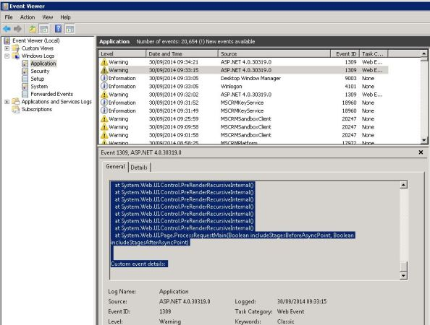

You can see there are a view warnings, a .NET, a sandbox. Be warned there is often a lot of noise in the event logs (e.g. warning and errors which are not important).
I looked the .NET error

Process information:
Process ID: 5348
Process name: w3wp.exe
Account name: DEV\CRMAPPPOOL
Exception information:
Exception type: CrmException
Exception message: The plug-in execution failed because no Sandbox Hosts are currently available. Please check that you have a Sandbox server configured and that it is running.
System.ServiceModel.EndpointNotFoundException: Microsoft Dynamics CRM has experienced an error. Reference number for administrators or support: #72E41A64
at Microsoft.Crm.Application.Platform.ServiceCommands.PlatformCommand.XrmExecuteInternal()
at Microsoft.Crm.Application.Platform.ServiceCommands.RetrieveMultipleCommand.Execute()
at Microsoft.Crm.Caching.DefaultSavedQueryIdCacheLoader.LoadCacheData(SavedQueryIdCacheKey key, IOrganizationContext context)
at Microsoft.Crm.Caching.CrmSharedMultiOrgCache`2.LookupEntry(TKey key, IOrganizationContext context)
at Microsoft.Crm.Caching.DefaultSavedQueryIdsCache.TryLookupEntry(Int32 objectType, Int32 savedQueryType)
at Microsoft.Crm.Application.Components.Sdk.FormControls.Web.LookupControl.ConfigureControl()
at Microsoft.Crm.Application.Components.UI.CrmUIControlBase.ConfigureControlInternal()

It pointed to the Sandbox service and when I checked the CRM services, I saw the sandbox service was stopped. I started the sandbox service and CRM popped back into life.

Check the CRM Asynchronous services
This should be your first thing to check because if the ASYNC services have stopped then CRM will stop working. If you want to learn more about CRM Asyncs, you can go here

- IIS
- Asynchronous service in Microsoft Dynamics CRM
To see if the Async services are running, Microsoft have a document for starting and stopping
- Navigate to Start, select Administrative Tools, and then click Services.
You should find there are four CRM Async services and you can see if they are started
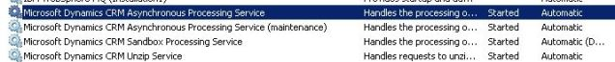
The Async processing service is usually the cause of CRM not working.
The problem displayed on this page was caused
If you have restarted the Asyncs and CRM is still not working
Check IIS is up and running
Go to the Start menu
Type IIS
It will bring up Internet Information Services (IIS) Manager
IIS is the webserver which hosts the Microsoft Dynamics CRM website. Some times you can find this may be stopped (very rarely but it’s something to check, so we can rule it out).
How frequently are we seeing the CRM Async service getting stopped?
Do we see any asynch related errors in the event viewer when it is stopped?
Is the Asynchoperationsbase table huge if yes then clean the table?
What is the update rollup installed on CRM server?
Is there anything else that occurs when this issue happens that could be contributing to the issue?
Did you tried restarting all the CRM services followed by IISRESET?

- Is the CRM Website up
if you click on the CRM website called Microsoft Dynamics CRM then the details of the web app will appear on the right, you need to check the start is greyed out (which means it is selected)
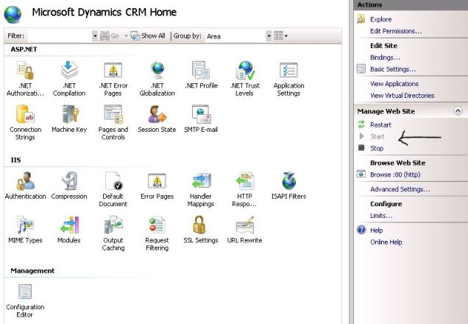

- SQL Server
I often think of CRM as a web application to show the contents of the CRM SQL database. If the SQL CRM instance is down, SQL server is off or can’t be contacted then CRM will stop working.
If CRM isn’t working you need to check the SQL server (usually on a different server) is up and running and the CRM instances are running.
There are a couple of things to check

